ZD,
REPORT OF JOINT INVESTIGATION VISIT BY NOSDRA, DPR, SPDC, BAYELSA STATE MINISTRY OF ENVIRONMENT AND PEREMABIRI COMMUNITY AT DIEBU CREEK FLOW STATION 24’’ FLARE HEAD LINE @ PEREMABIRI IN SOUTHERN IJAW LGA OF BAYELSA STATE.
INTRODUCTION
Acting on your directives on the SPDC request latter sent in dated 7th September 2015, a Joint Investigation Visit (JIV) was conducted at the Diebu Creek Flow Station 24’’ Flare Head Line at Peremabiri in Southern Ijaw Local Government Area of Bayelsa State on the 4th of September, 2015 at about 14:30Hrs. The investigation was completed successfully on the same day. This report provides details.
INCIDENT PARTICULARS: 2015_1479080
FACILITY AFFECTED: DIEBU CREEK FLOW STATION 24’’ FLARE HEAD LINE @ PEREMABIRI IN SOUTHERN IJAW LGA OF BAYELSA STATE.
DATE OF SPILL: 03/09/2015
DATE OF INSPECTION: 04/09/2015
CAUSE OF SPILL: OPERATIONAL ERROR (Environmental Upgrade Failure)
QUANTITY OF CRUDE OIL SPILLED: 21.07 Barrels (Approximately 22 Barrels)
SPILL POINT COORDINATES: N 04^{O} 39’ 37.9’’
E 006^{O} 04’ 42.8”
NATURE OF IMPACT:
INVESTIGATION TEAM:
- Koms Abam NOSDRA
- Kalio S. H. SPDC
- Duruaku V. SPDC
- Chibuike Chibuzo DPR
- TimiTimi Tariwari BAYELSA STATE MINISTRY OF ENVIRONMENT
- Chief Noel Imgbila PEREMABIRI COMMUNITY
- Ime Effiong NIGERIAN POLICE FORCE
OBSERVATIONS:
- A 24’’ Pipe Line running from the Flow Station to the Flare Head was undergoing Environmental Upgrade and the ‘Cut’ leaked during the operation, discharging some volume of Crude Oil into the Environment and Water Body. (See Fig. 1a & b)
- The Spill occurred in-between the Flow Station and the Flare Pit – just about a distance of 50M to the Pit. (See Fig. 2a & b)
- It was a clear case of Operational or Maintenance Error. The process involves first, flushing out the Oil from the Pipe as much as possible to the Flare Pit before commencing ‘Cold Cutting’ for the Upgrade but the process was not followed through properly. Hence there was a drop in pressure from the 16’’ Pipe Line linking to the Flare Stack - after the cut, which lead to the discharge of Crude Oil into the Environment.
- The Oil was naturally contained by Water Hyacinth and other Aquatic Plants around the Flow Station, and Bund Walls at the Flare Pit (See Figs. 2b and 3a & b) though the water may have carried some of the Crude into the adjourning Environment. (See Fig. 4a & b)
- Total Area of impact was calculated to cover 0.739 Ha within SPDC ROW.

ISSUES OF CONCERN - FEED BACK
- The back – flow would have been avoided if the process of flushing the Pipe Line was followed through and double checked before the Cold Cutting.
RECOMMENDATIONS
- Clean-up should be carried out immediately.

CONCLUSION
The JIV was successful. This report is subject to your steer and further directives.
Koms Abam
SES
_____________________________
DATE: 05th September, 2015

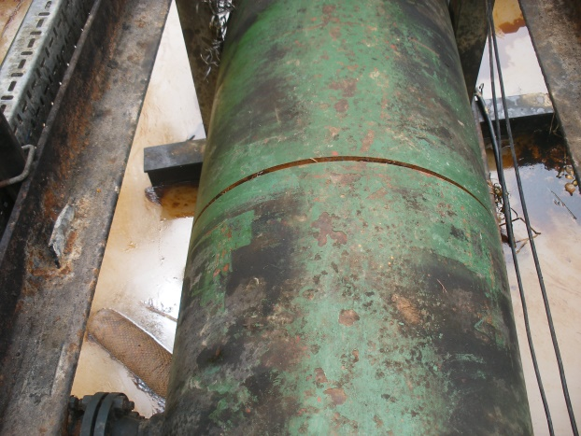 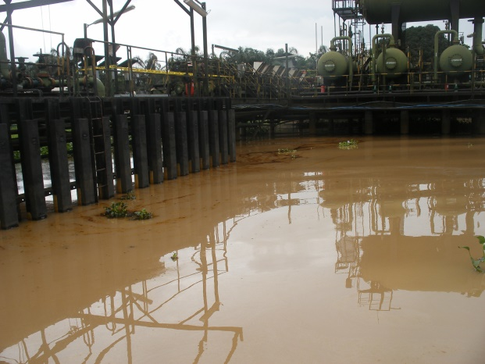 Fig. 1a Cut on 24’’ Pipe - Environmental Upgrade Fig.1b Flow Station
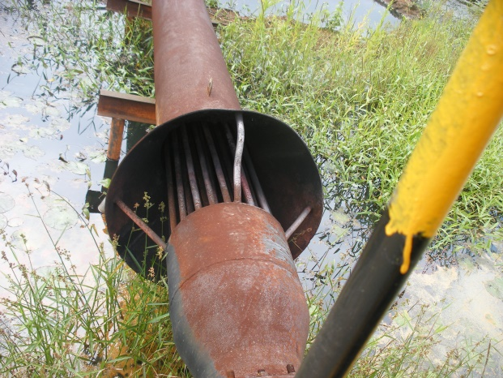 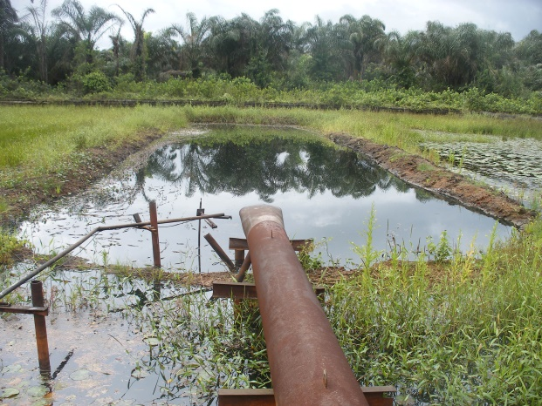 Fig. 2a Flare Head Fig. 2b Flare Pit showing Free Phase Oil Pool.
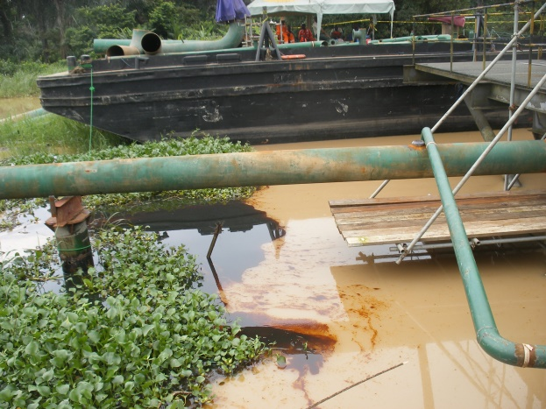 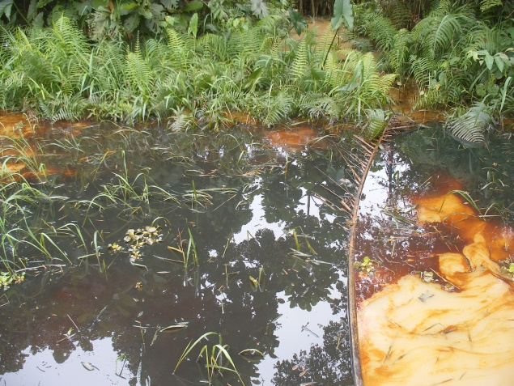 Fig. 3a Crude contained by Water Hyacinth. Fig. 3b Containment by other Aquatic Plants.
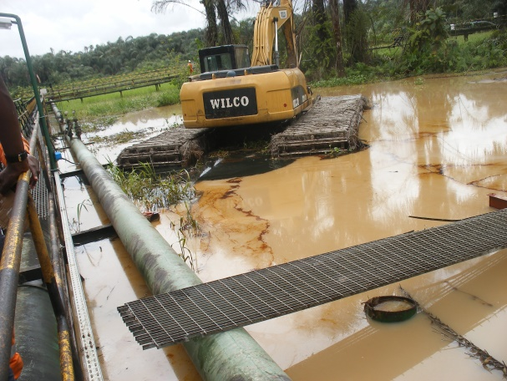 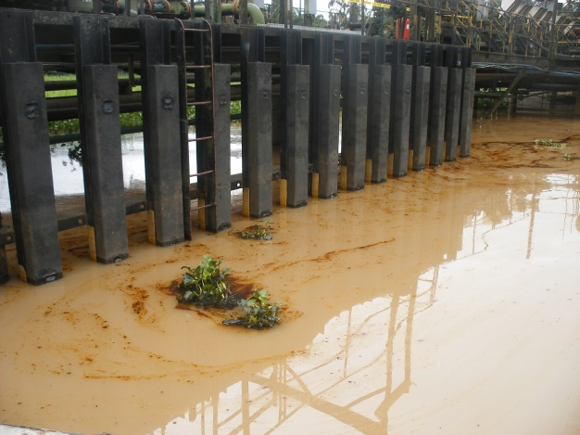 Fig. 4a Adjourning Environment Polluted. Fig. 4b Crude carried away by Water.

